FUTURE INTERNS – INTERNSHIP TASK SUBMISSION
Name: SHREE DHARINI R K
Domain: Prompt Engineering
Task Number: 01
Repository Name: future_PE_01

1. Task Overview
This task required the application of prompt engineering principles to create assets for an AI-generated YouTube short. The objective was to engineer effective prompts to generate a compelling video title, a structured script, and a relevant thumbnail. The final outputs were compiled into a video using an AI video creation tool and documented in a GitHub repository for submission.

2. Tools Used
- ChatGPT (for text generation)
- Pictory AI (for video creation)
- AI Image Generator (DALL·E / Bing Image Creator)
- GitHub (for repository and version control)
- Google Docs (for documentation)

3. Prompt Engineering Workflow
This section details the specific prompts engineered to generate each required component.
Prompt for YouTube Title Generation:
"You are a YouTube SEO expert specializing in viral shorts. Generate 10 attention-grabbing, short, and provocative titles for a 60-second YouTube short about how everyday people can use new AI tools to make money online. Focus on curiosity and direct value."
Prompt for YouTube Script Generation:
"Write a concise, energetic YouTube short script for the title '[Selected Title Here]'. The script must be exactly 60 seconds long when read at a moderate pace. Structure it as follows:
- A strong hook in the first 3 seconds.
- Present a common problem or desire.
- Introduce AI tools as the solution (mention 2-3 specific, popular tool categories).
- Give one clear, actionable first step.
- End with a motivating call-to-action to learn more.
Use bold text for on-screen keywords and instructions for visual cues in parentheses."
Prompt for Thumbnail Text Selection:
"Analyze the following YouTube short script. Extract the 3 most impactful, high-emotion, or curiosity-driven keywords or phrases that would be best as large text on a video thumbnail. Output only the phrases."
Prompt for Thumbnail Image Generation:
"A cinematic hyper-realistic thumbnail for a YouTube video. Central visual of a human hand reaching towards a glowing, complex AI circuit board or digital brain, with gold coins or currency symbols emerging from it. Dark, futuristic background with focused lighting. Digital art style, high contrast, visually striking."

4. Selected YouTube Title
AI = MONEY?

5. YouTube Script
The following script was generated using the prompt engineering techniques detailed in Section 3.
(Start Script)
(Hook: 0-3 sec)
"Think AI is just for tech giants? You're wrong. It’s now your fastest path to making money online."
(Scene: Creator looking frustrated at laptop)
"Stuck trading hours for dollars? Want an income stream that works while you sleep?"
(Visuals: Fast-paced montage of AI tools in action)
This is where AI changes everything.
Use AI writing tools to create e-books and blog content in minutes.
Turn ideas into visuals with AI image generators for print-on-demand or social media.
Automate client work with AI for video editing, coding, and design.
(Scene: Split-screen showing a simple prompt and the output it creates)
Your first step is simple. Don't learn everything. Pick ONE skill you already have and find the AI tool that supercharges it. A single hour of research today can unlock a new revenue stream by tomorrow.
(Final Call-to-Action)
Stop watching. Start building. Your future bank account will thank you. Subscribe for the next step."
(End Script - 60 seconds)

6. Thumbnail Details
- Thumbnail Text: AI = MONEY?
- Concept Explanation: The thumbnail concept was derived by feeding the selected title and script into the AI image generation prompt (as shown in Section 3). The prompt combined the core theme (AI and money) with specific visual directives (style, composition, mood) to guide the AI in creating a relevant, eye-catching image suitable for a YouTube short.
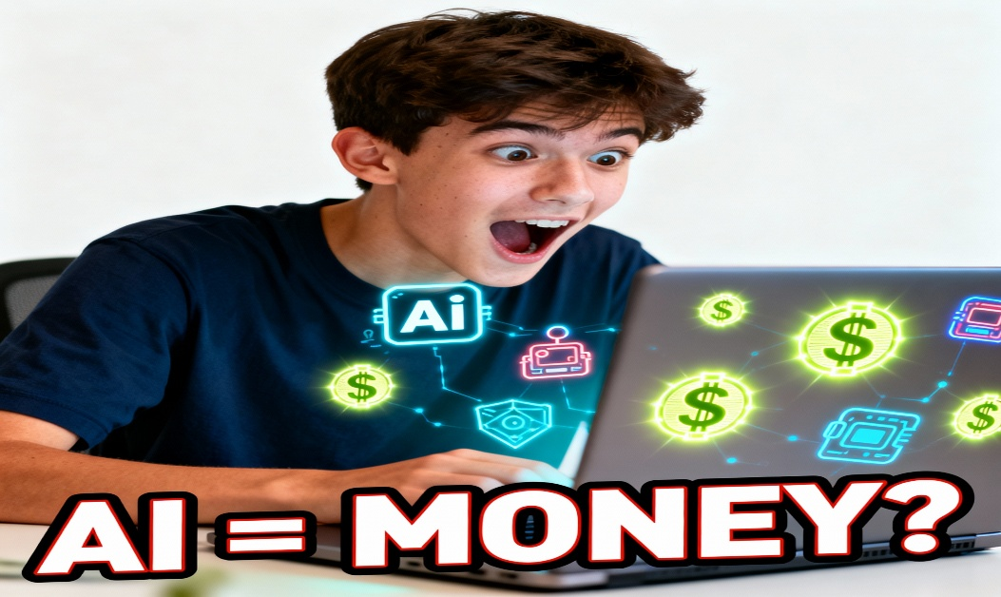
7. Video Creation
- Tool Used: Pictory AI
- Video Link: https://video.pictory.ai/20251224150951018f9177781846a409c814377d889f96251/20251224151801165yPcsMA4eIwMkqJZ

8. GitHub Repository
- Repository Name: future_PE_01
- Repository Link: https://github.com/rkshreedharini/FUTURE_PE_01
- Contents Description: This repository contains all task deliverables and documentation, including:
  - A detailed record of all prompts used.
  - The final selected script and alternative drafts.
  - Generated thumbnail images and assets.
  - This submission document.
  - The README file providing an overview of the project.

9. Conclusion
This task provided a practical, hands-on exploration of end-to-end AI-assisted content creation. Key learnings include the critical importance of precision, context, and iterative refinement in prompt engineering. A well-structured prompt, specifying format, tone, length, and key elements, directly translates to higher-quality, more usable AI outputs. The process of chaining prompts—using the output of one (like the title) as input for the next (like the script)—effectively simulates a professional content workflow. This exercise demonstrated that prompt engineering is less about issuing commands and more about crafting clear, collaborative instructions to guide AI toward a specific creative goal.

Submitted by: SHREE DHARINI R K
Internship: Future Interns
Domain: Prompt Engineering

